
UNIVERSITY OF FRONTIER TECHNOLOGY, BANGLADESH
Department of Cyber Security Engineering
Lab Manual

Name of the Manual : Windows Log Analysis with PowerShell
Manual No : 01
Course Title : Threat Modelling and Security Monitoring Sessional
Course Code : SEC 204

Submitted By:  Name : Afra Anjum Odhora  Student ID : 2404025  Level : 2  Term : 1  Department of Cyber Security Engineering, UFTB | Submitted To:  Name : Md Masud Rana  Designation : Lecturer  Department of Cyber Security Engineering, UFTB

Objective

Use PowerShell to analyze Windows Security Event Logs and detect security incidents such as brute-force attacks, lateral movement, and privilege escalation.

PowerShell Event Log Queries

Step: Open PowerShell as Administrator

1. Press Win + X
2. Select Terminal (Admin).
3. Verify the version.

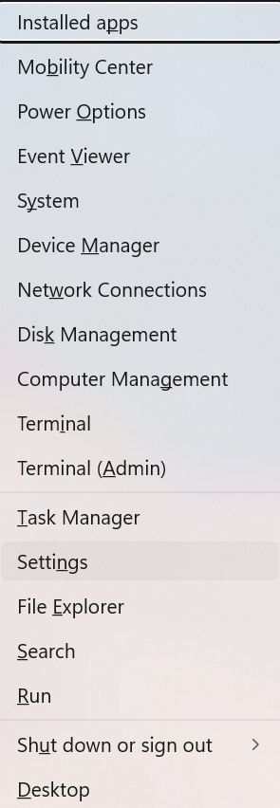

Basic PowerShell Event Log Queries

Exercise 1: View Recent Security Events

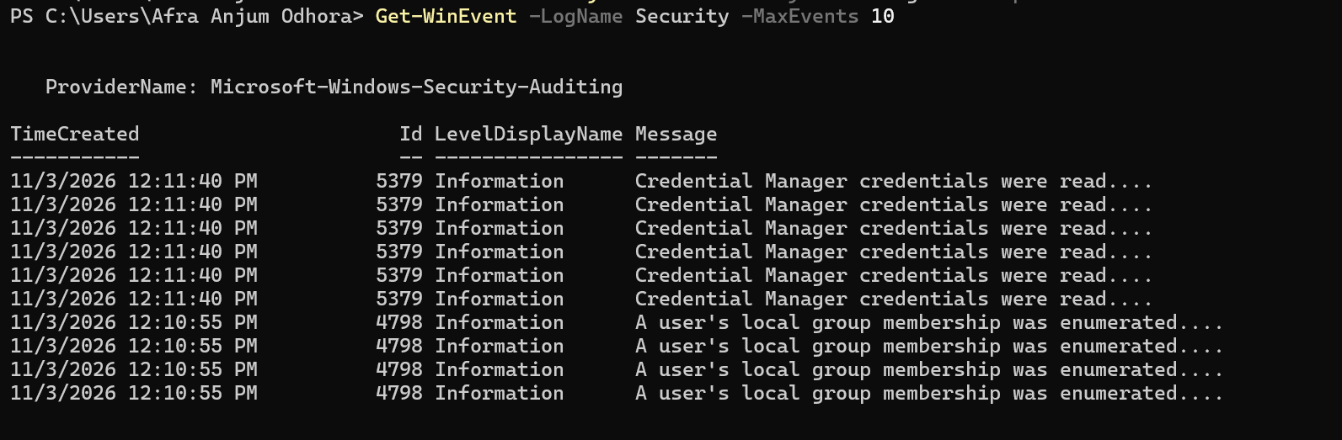

- ‘Get-WinEvent’ retrieves event logs.
- ‘-LogName Security’ selects the Security log.
- ‘-MaxEvents 10’ limits output to the 10 most recent events.

Exercise 2: Filter by Event ID

View the last 20 successful logons (4624):

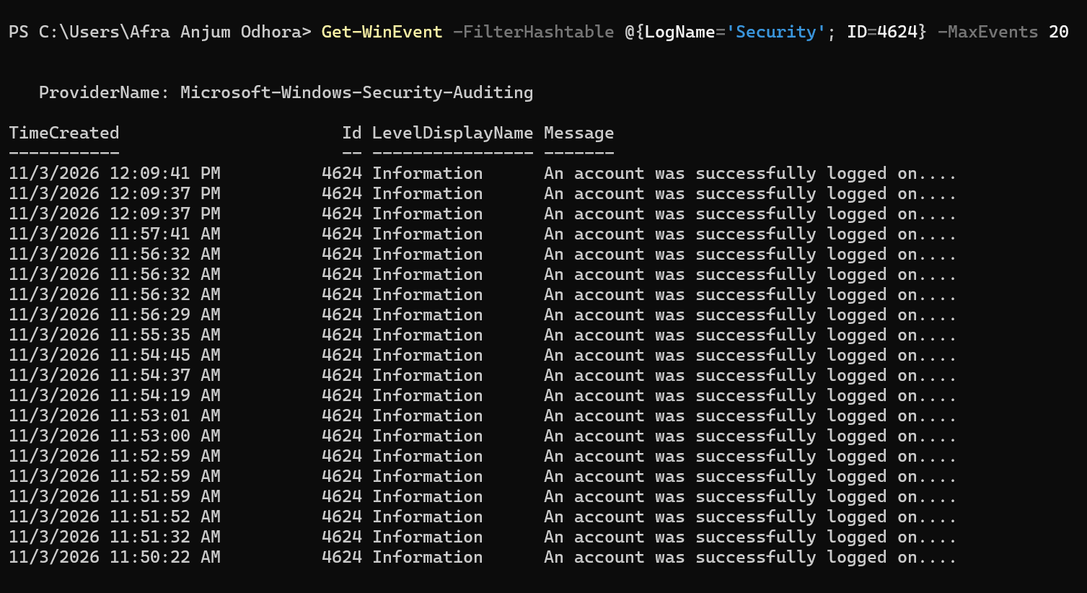

Explanation:
- -FilterHashtable = efficient filtering method
- @{LogName='Security'; ID=4624} = hashtable with filter criteria

Exercise 3: Filter by Time Range

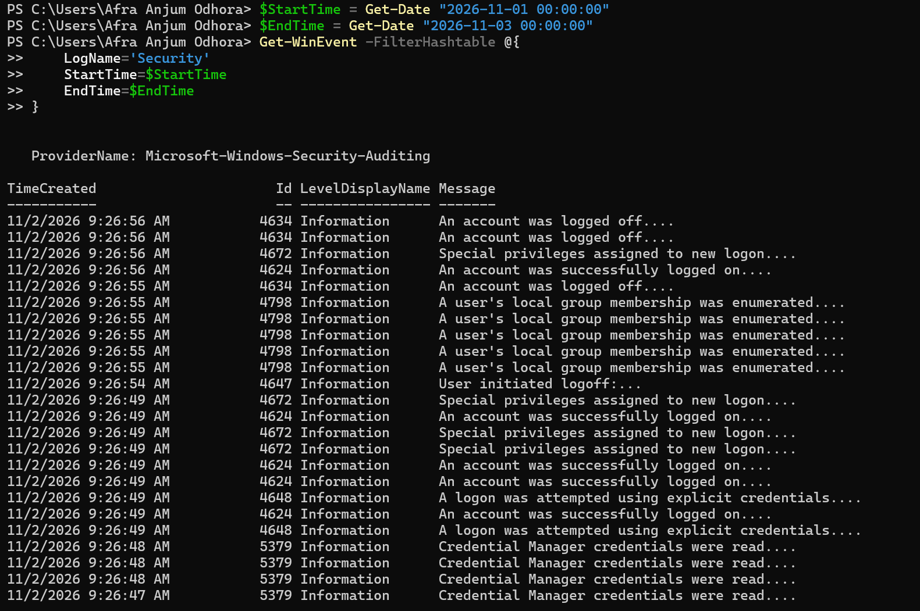

Explanation:
- (Get-Date).AddDays(-1) = 24 hours ago
- StartTime=$StartTime = filter from that time forward

Exercise 4: Count Events

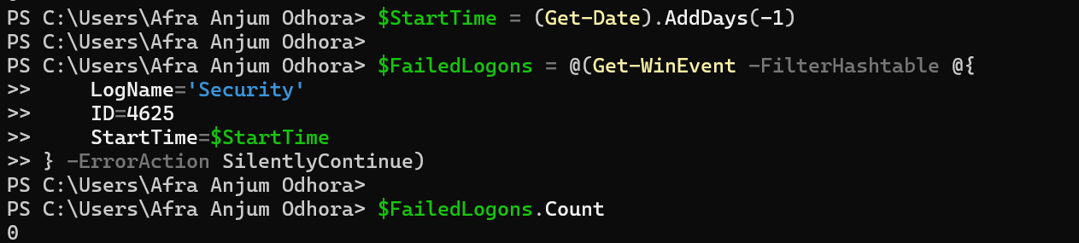

Explanation:

- Get-WinEvent – Retrieves event logs from Windows.
- -FilterHashtable – Filters event logs using specific conditions.
- LogName='Security' – Searches in the Windows Security log.
- ID=4625 – Finds failed logon attempts.
- StartTime=$StartTime – Searches events from the last 24 hours.
- $FailedLogons – Stores all the matching failed logon events.

Extracting Event Properties

Exercise 5: Understanding Event Structure

Windows events are stored as XML.

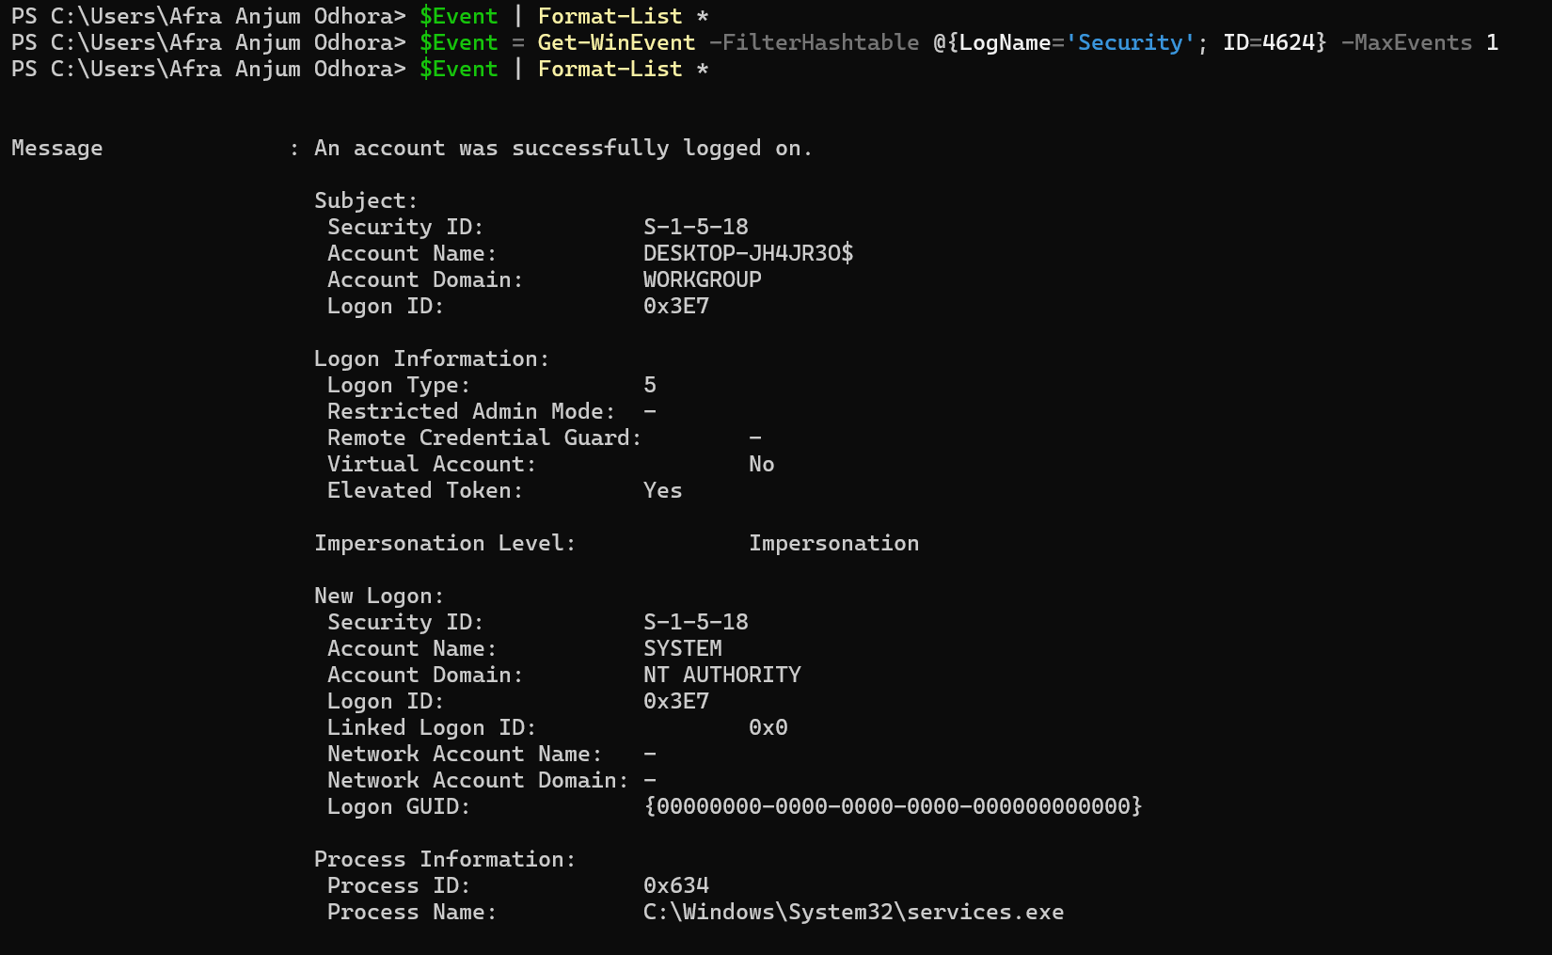

Explanation:

- $Event – Accesses the stored event.
- | (Pipeline) – Passes the event to the next command.
- Format-List – Displays event information in a list format.
- – Shows all available properties of the event.

Exercise 6: Extract Data from Failed Logons (4625)

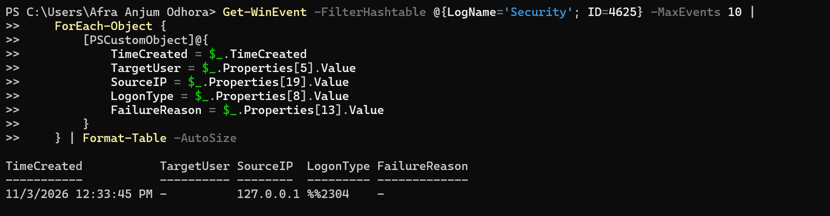

Explanation:
- ForEach-Object – Processes each event one by one.
- $_ – Represents the current event being processed.
- PSCustomObject – Creates a custom object to display selected event

Exercise 7: Top 5 Source IPs of Failed Logons

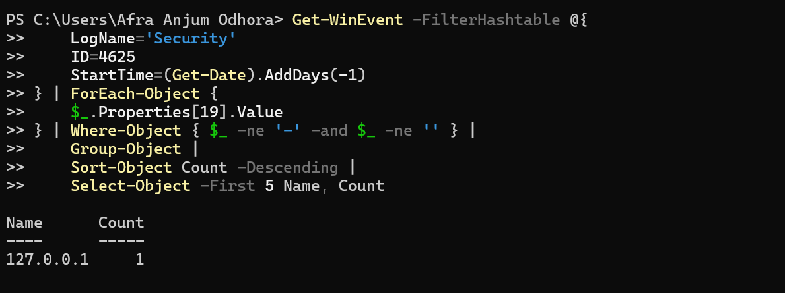

How it works:

- Get all 4625 events.
- Extract IP (index 19).
- Drop empty values.
- Group by IP.
- Sort descending.
- Take top 5.

Exercise 8: Top 5 Targeted Usernames

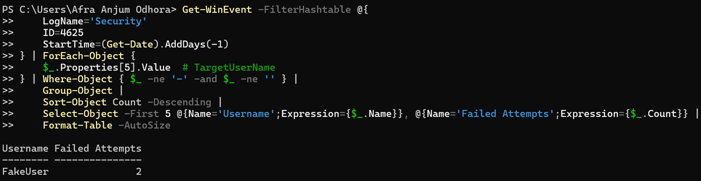

Explanation:

- Where-Object – Filters the extracted usernames.
- -ne – Means Not Equal.
- Removes - and empty usernames.
- Groups identical usernames together.
- Counts how many failed logon attempts belong to each username.
- Sorts usernames based on the number of failed attempts.
- -Descending – Displays the highest cou
- Select-Object – Selects specific information.
- -First 5 – Displays only the top five usernames.
- Username – Displays the username.
- Failed Attempts – Displays the total failed attempts for each username.

Exercise 9: Logon Type Distribution (Failed Attempts)

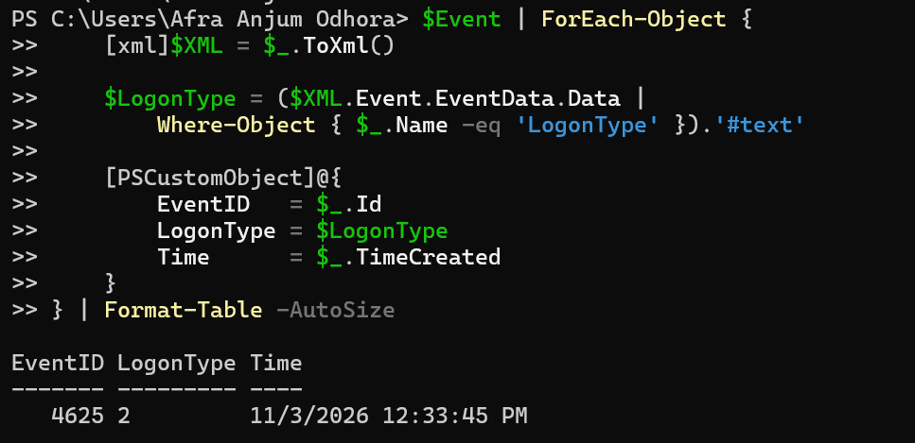

Detecting Brute-Force Attacks

Exercise 10: Identify Brute-Force Patterns

A brute-force attack typically shows:

- Many failed logons from the same source IP.
- Attempts against multiple usernames.
- Attempts within a short time window.

- Create ‘Detect-BruteForce.ps1’ file.

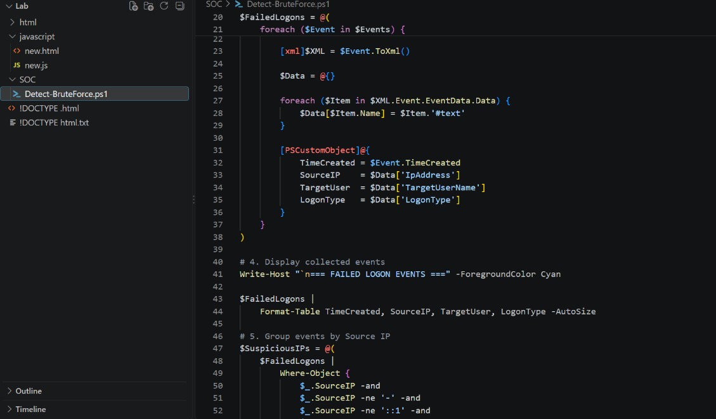

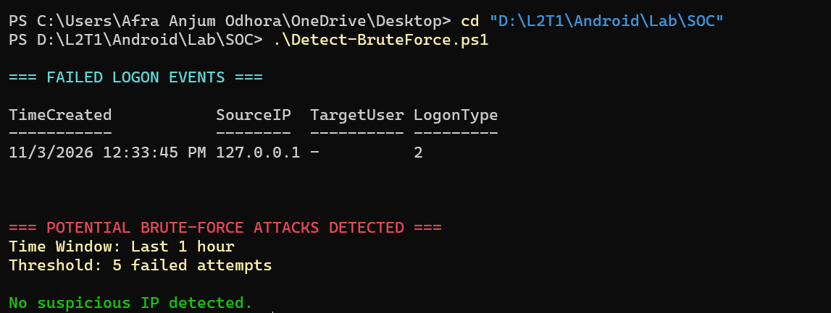

Exercise 11: Generate Test Failed Logons

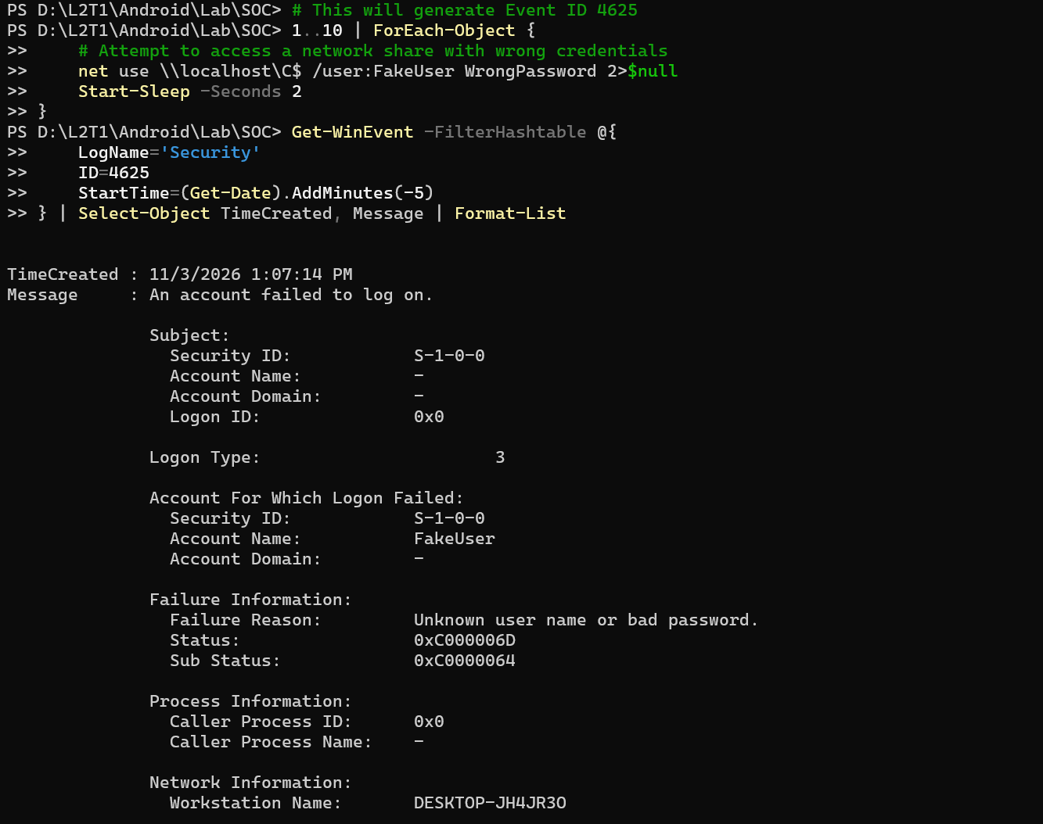

Detecting Lateral Movement

Exercise 12: Explicit Credential Usage (Event 4648)

Event ID 4648 indicates someone used explicit credentials (RunAs, PsExec, etc.) - common in lateral movement.

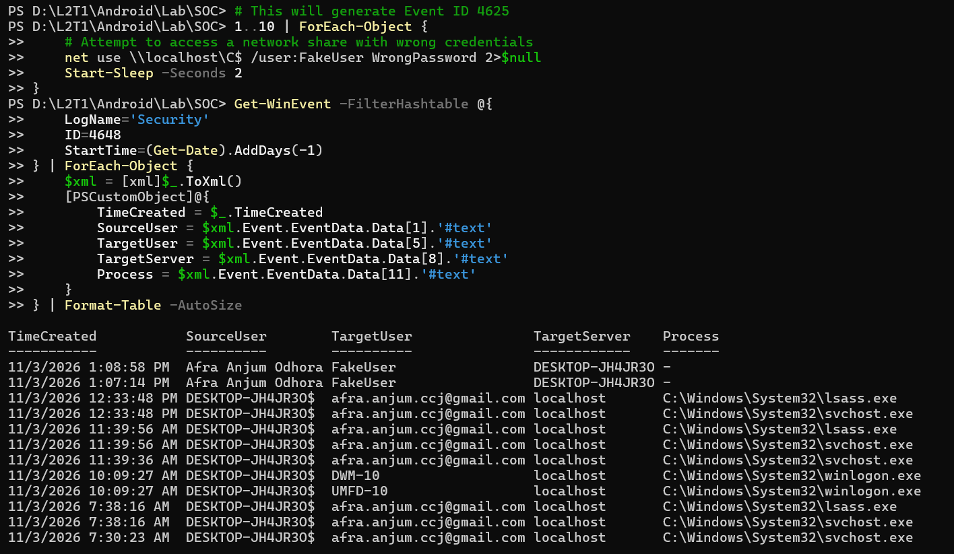
Explanation:
- $xml = [xml]$_.ToXml() – Converts the event details into XML format.
- 8. TimeCreated – Displays the date and time of the event.
- 9. SourceUser – Shows the user account that started the process.
- 10. TargetUser – Shows the user account whose credentials were used.
- 11. TargetServer – Displays the target server or computer name.
- 12. Process – Shows the process name that used the credentials.
- 13. [PSCustomObject] – Creates a custom object to organize the event information.

Exercise 13: Network Share Access (Event 5140)

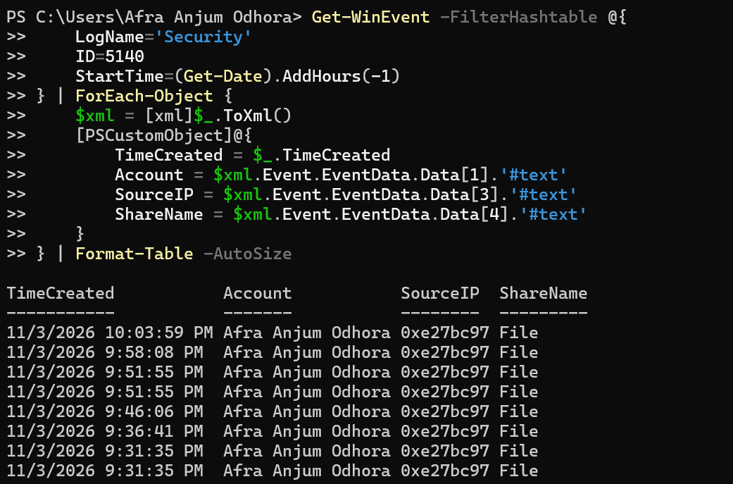

Detecting Privilege Escalation

Exercise 14: Admin Group Changes (Event 4732)

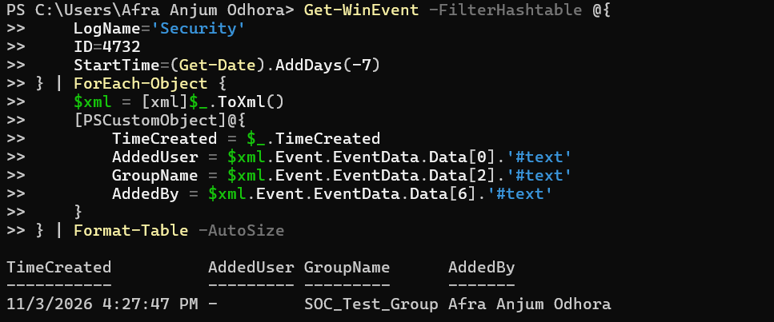
Exercise 15: Special Privilege Assignments (Event 4672)

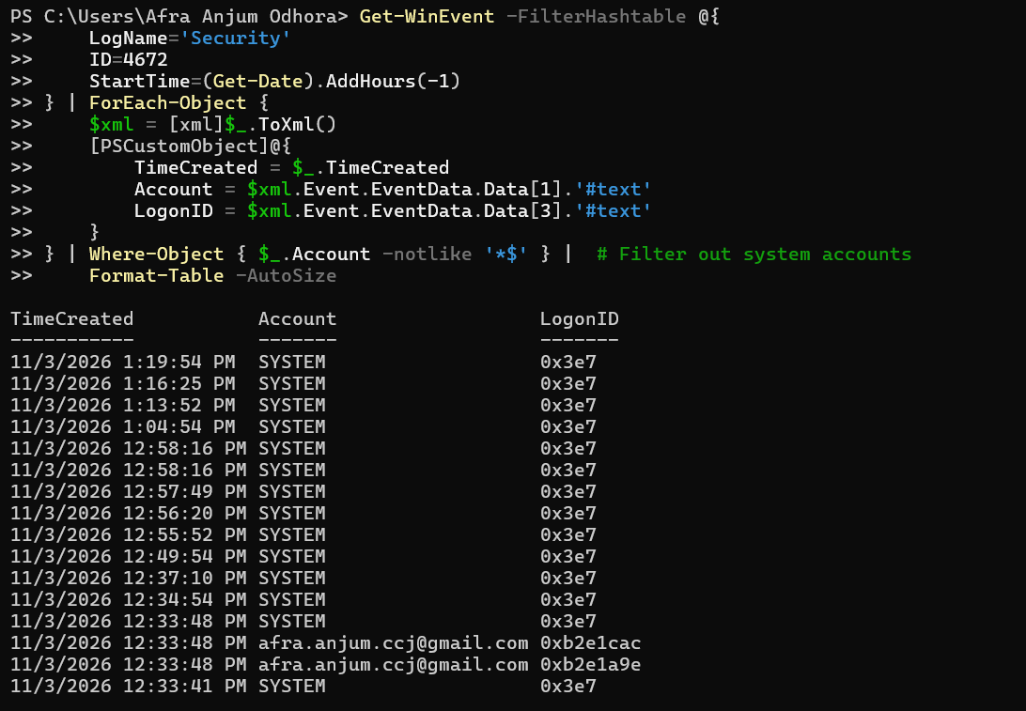

Complete Analysis Script

Exercise 16: Analyze-SecurityLogs.ps1

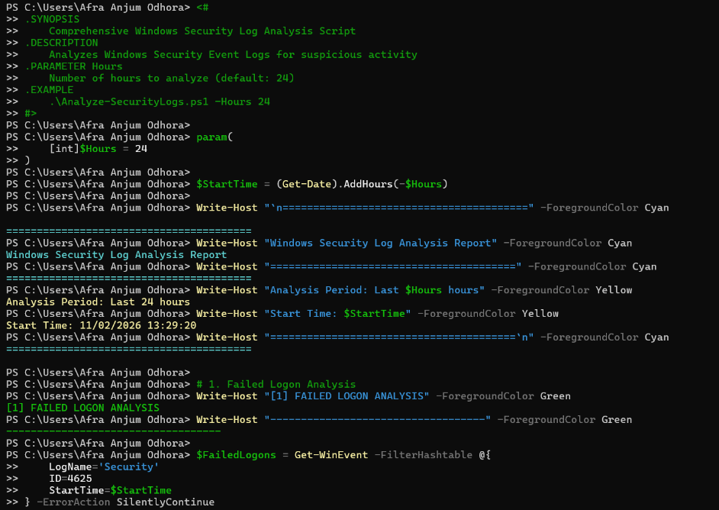

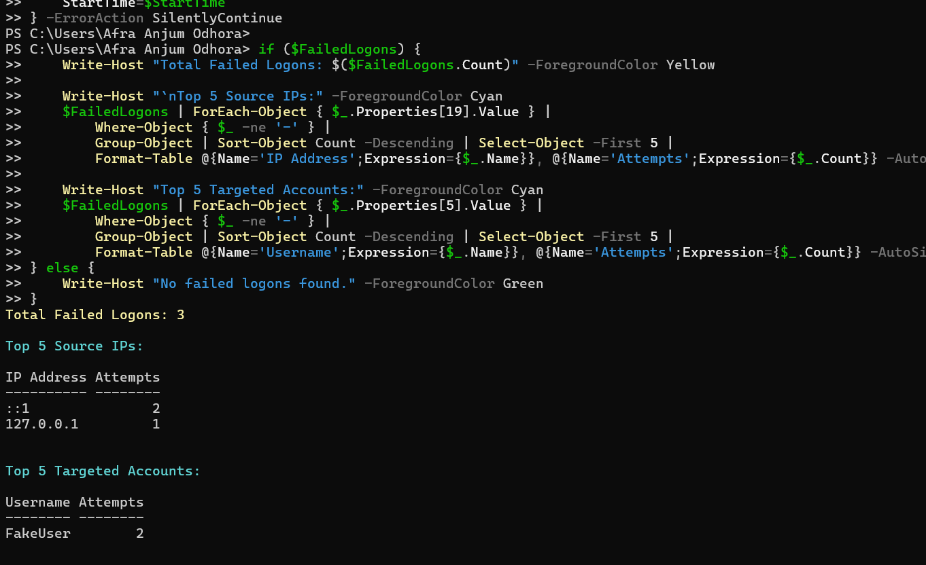

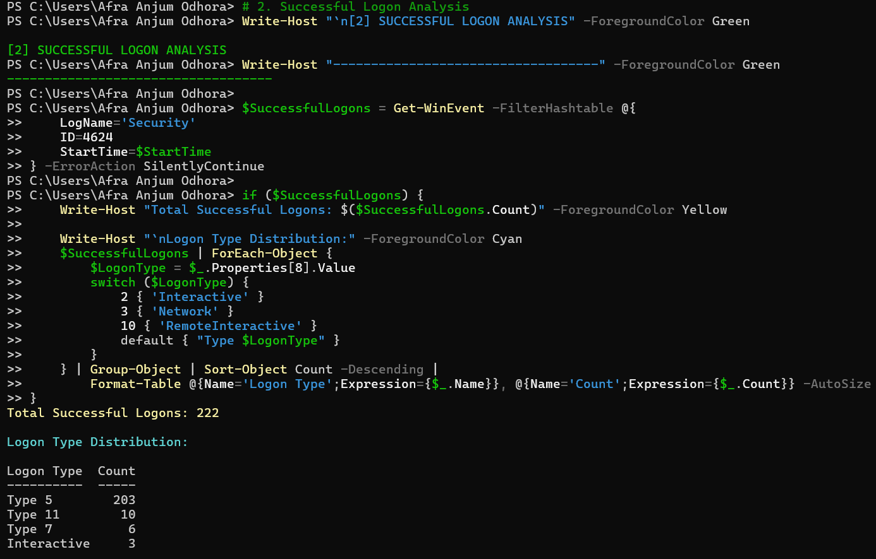

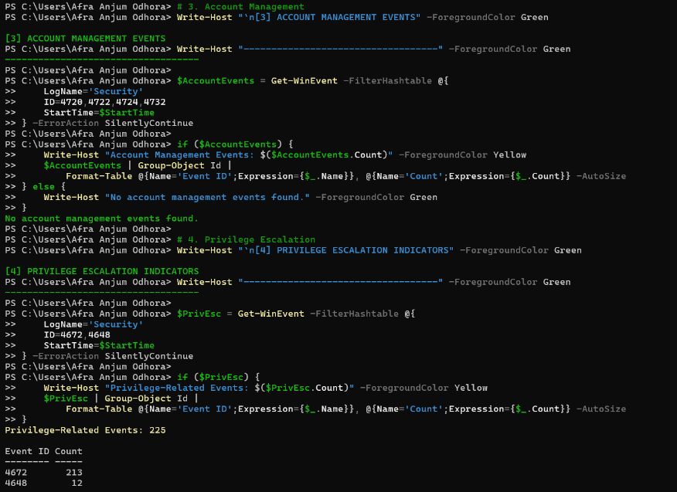
Exporting Results

Exercise 17: Export to CSV

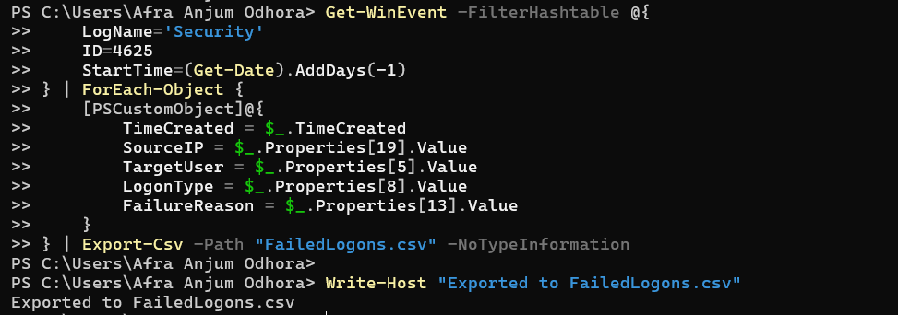

Exercise 18: Export to HTML Report

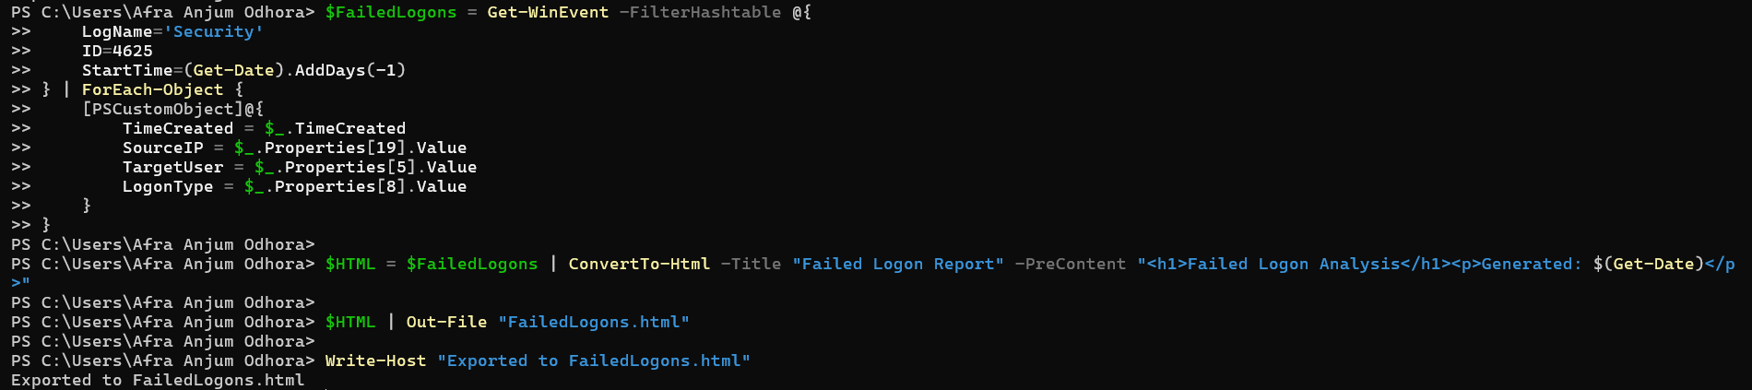

Conclusion

In this lab you used PowerShell to query, filter, and parse Windows Security Event Logs, detect brute-force attacks through repeated 4625 events, spot lateral movement through 4648 and 5140, track privilege escalation through 4732 and 4672, and automate the process into reusable scripts with CSV/HTML reporting.

